21-04-2024

FSx Hands on

Lab 2 >>> FSx for windows

MS Active Directory

min 2 hours

Directory Service >>> place your order

45 mints max

FSx for windows Lab

Step 1 - Create a Dedicated SG (< 3 mints)

Step 2 - Create a MS Directory Service (20 to 45 Mints) (Free for ONE month from your Date of creation)

Step 3 - Create your windows EC2 instances if not already created (< 5 mints)

Step 4 - Create a FSx only after your domain is ready (15 - 20 mints)

Step 5 - Map or mount your FSx on the above windows EC2 (< 5 mints)

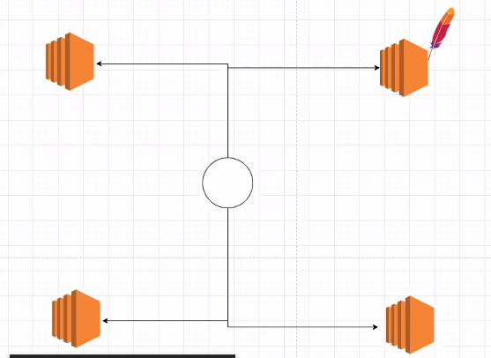

Step 1 - Create a Dedicated SG (< 3 mints)

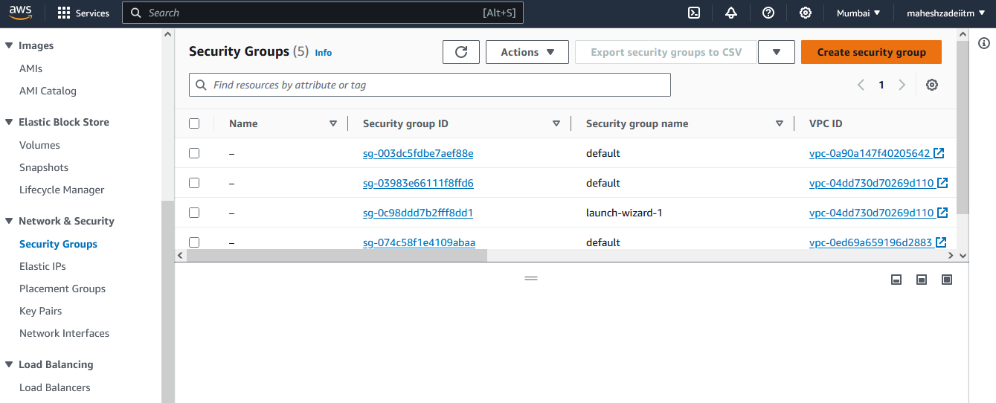

Name - FSx-SG

Description - FSx-SG

Choose your VPC

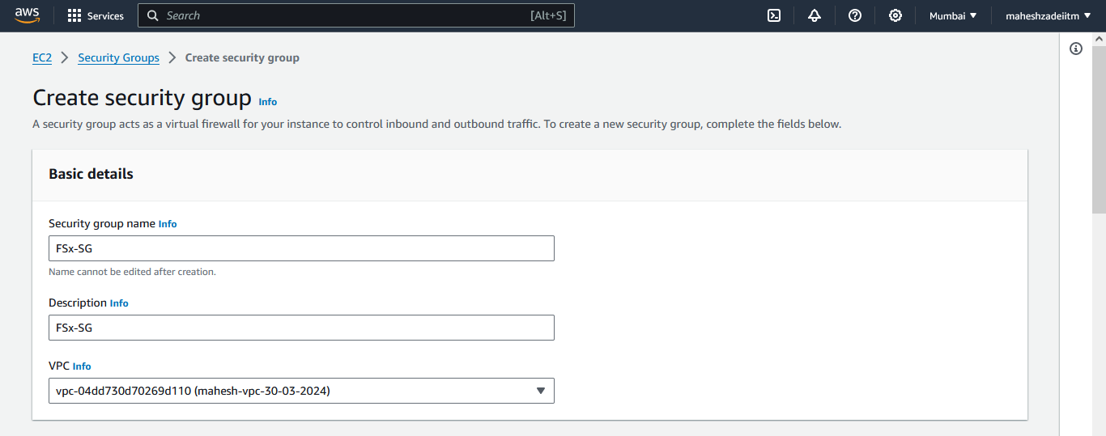

ALL TCP >> Anywhere

NFS >>> Anywhere

Add security group which we created.

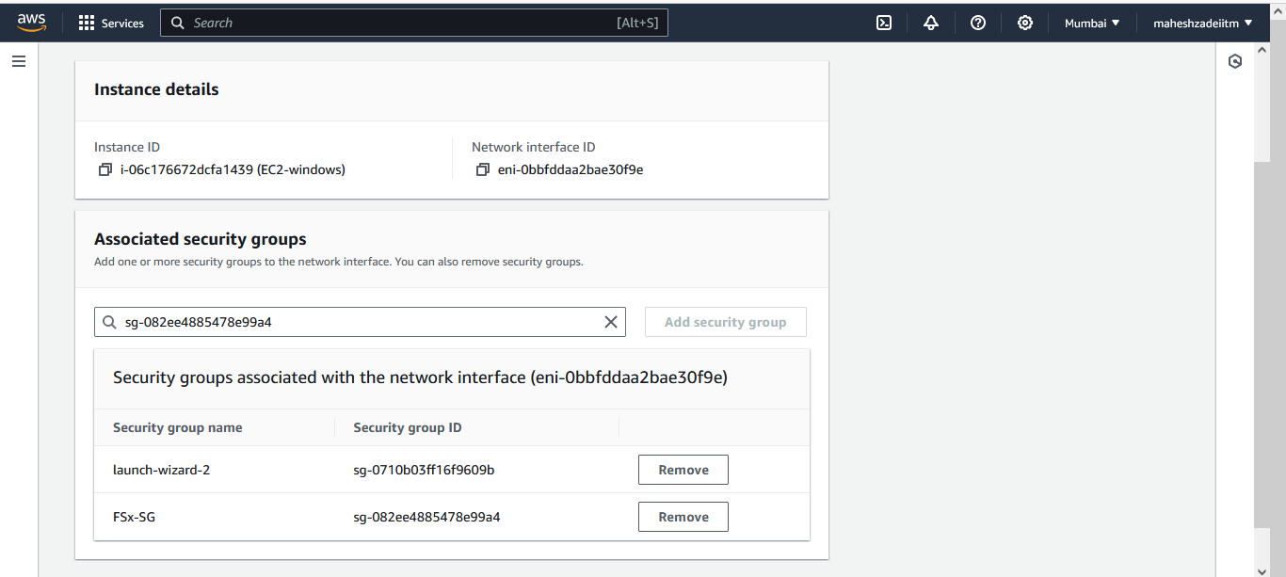

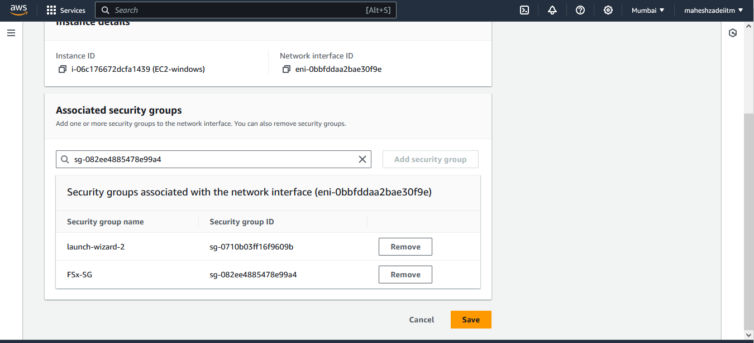

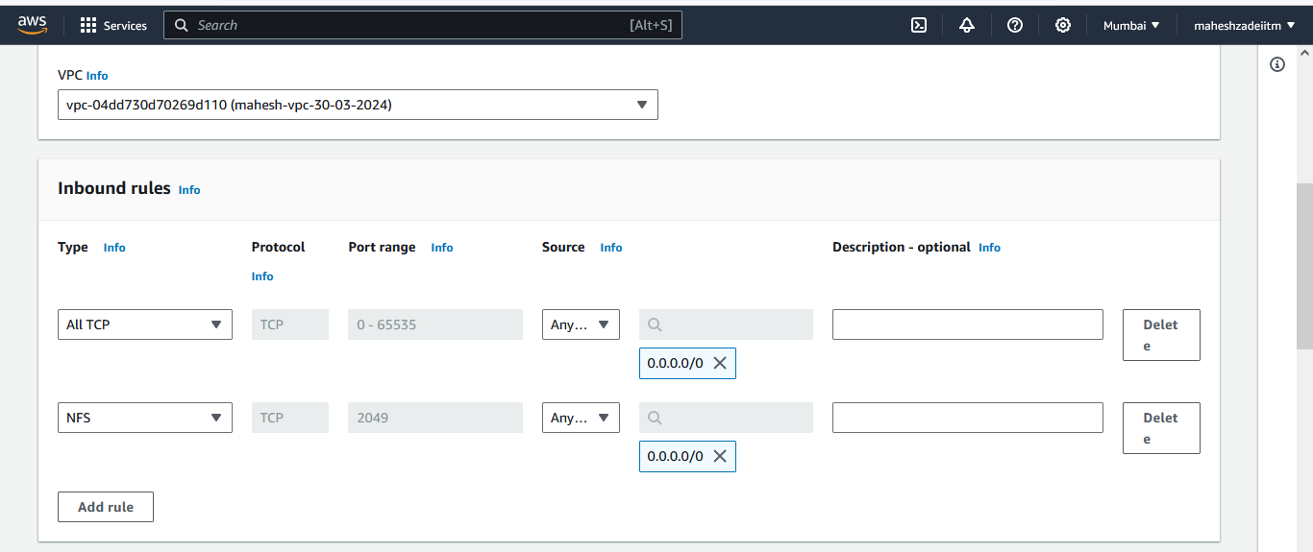

Outbound all traffic

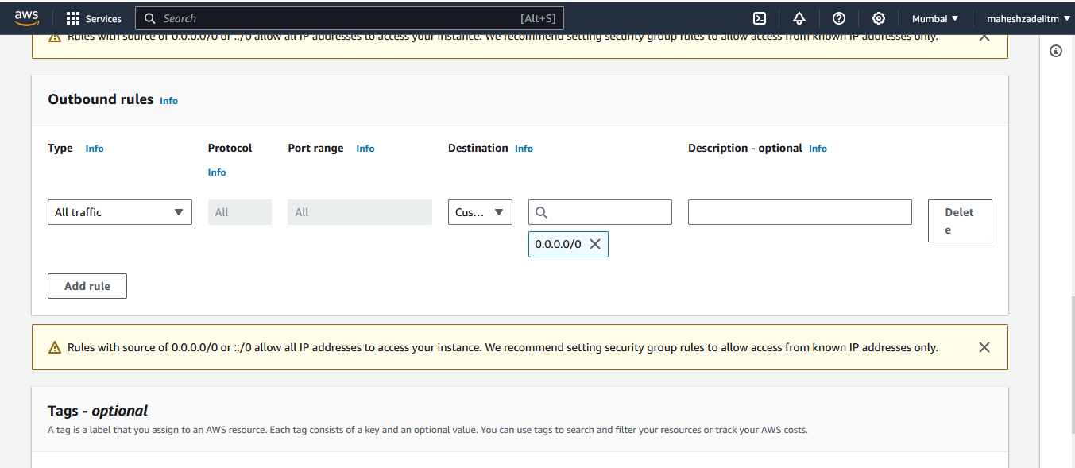

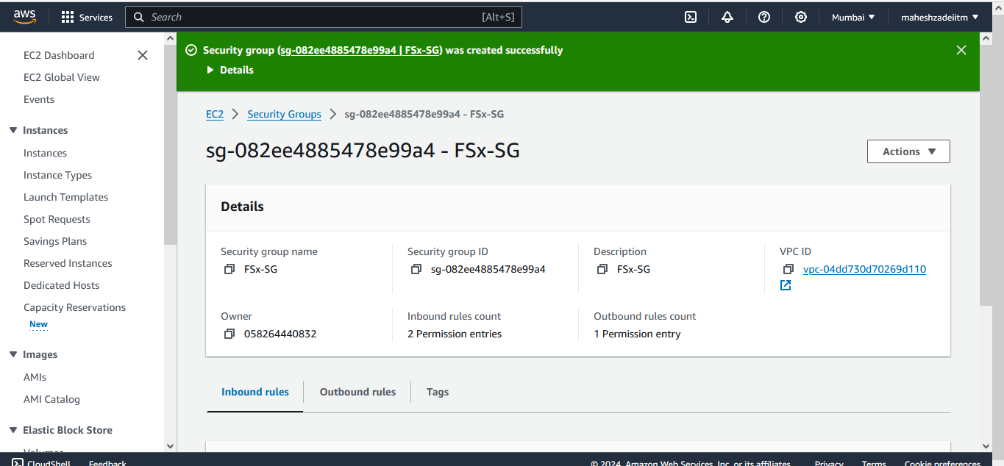

Security group Created

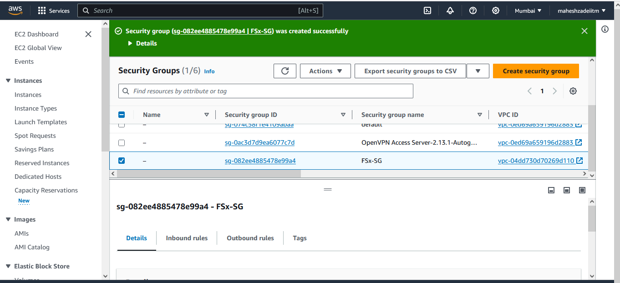

Step 2 - Create a MS Directory Service (20 to 45 Mints)

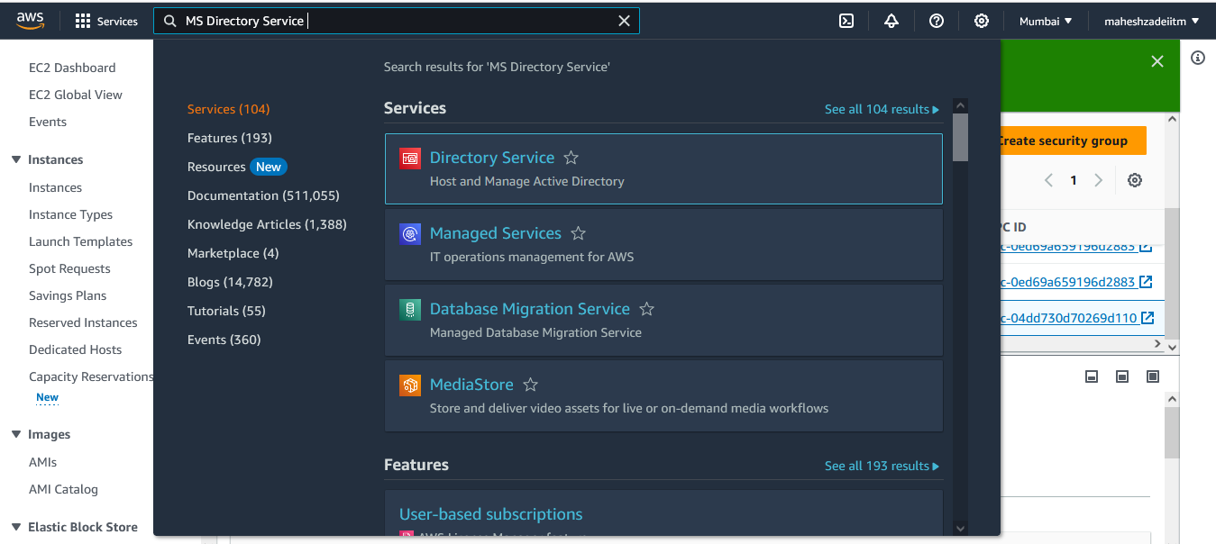

Set up directory >>> AWS Managed Microsoft AD >>> Set up directory

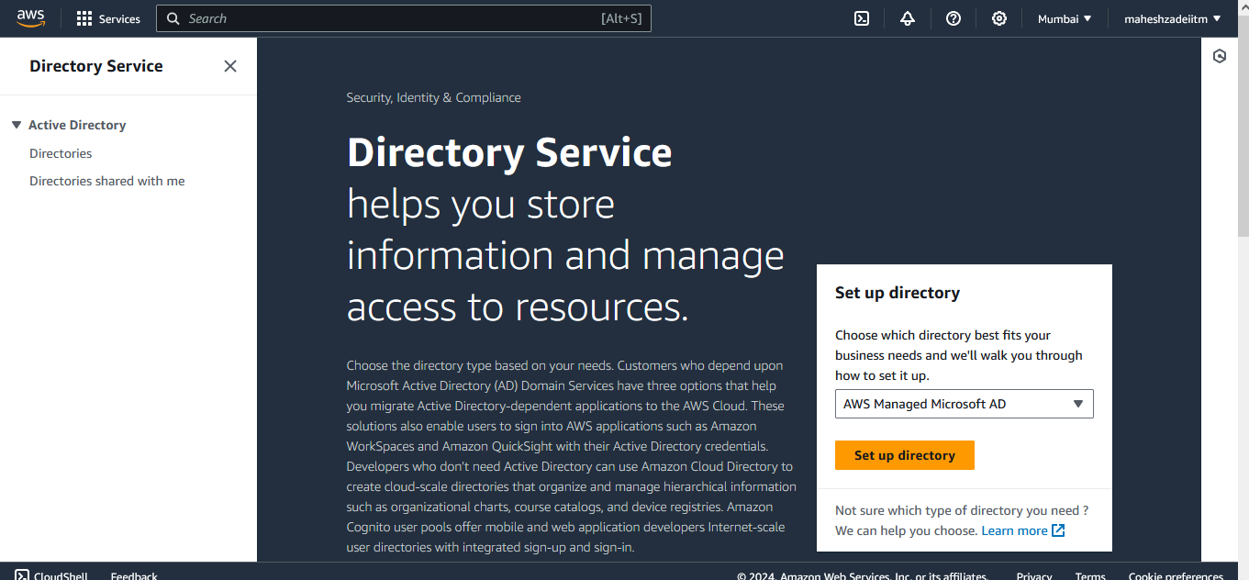

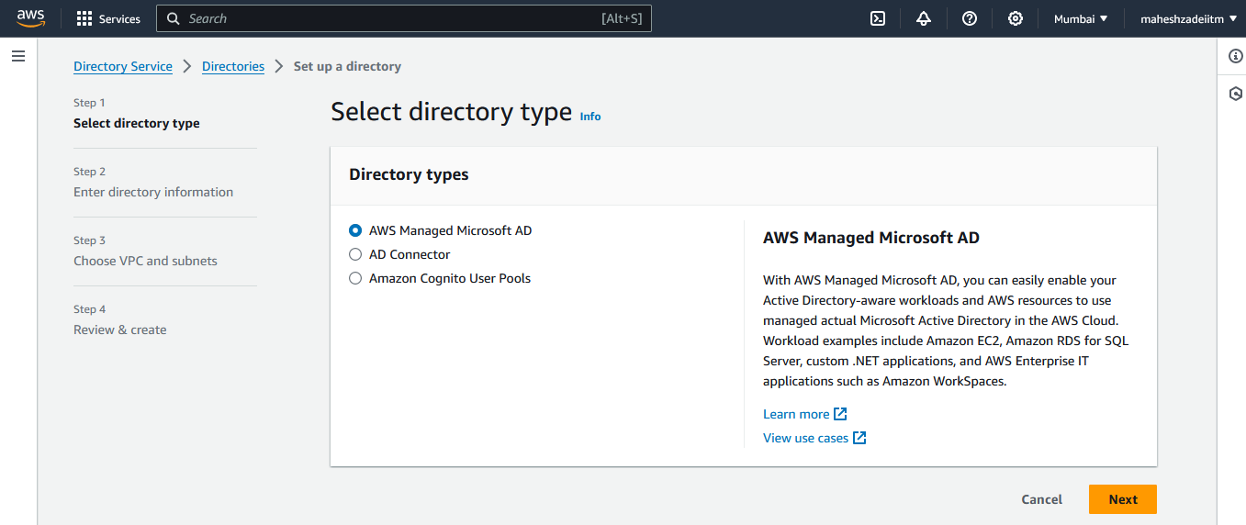

Next

Edition >>>> Standard Edition

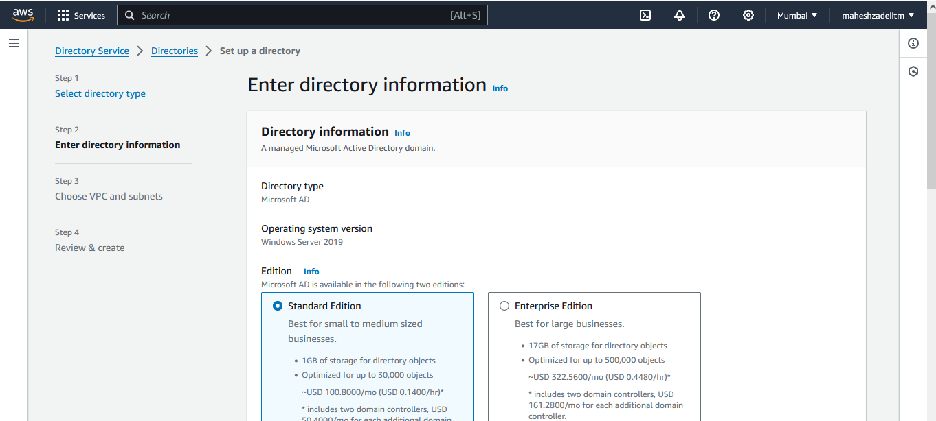

Directory DNS name >>>> maheshzade.com

Directory NetBIOS name - optional >>> maheshzade

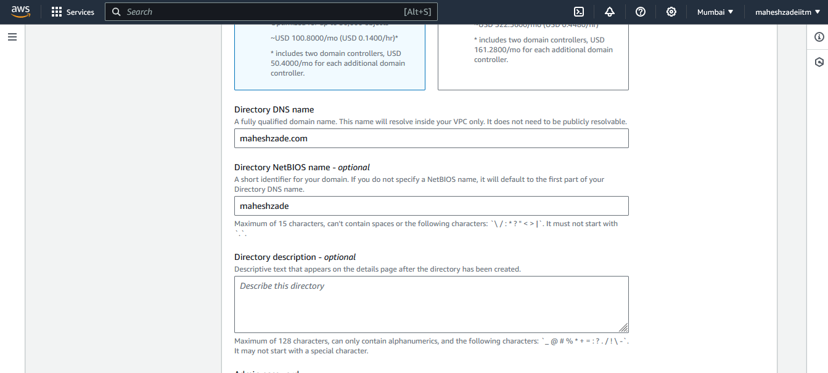

Admin Password >>> repeat and make a note of it

Password is India@123

Next

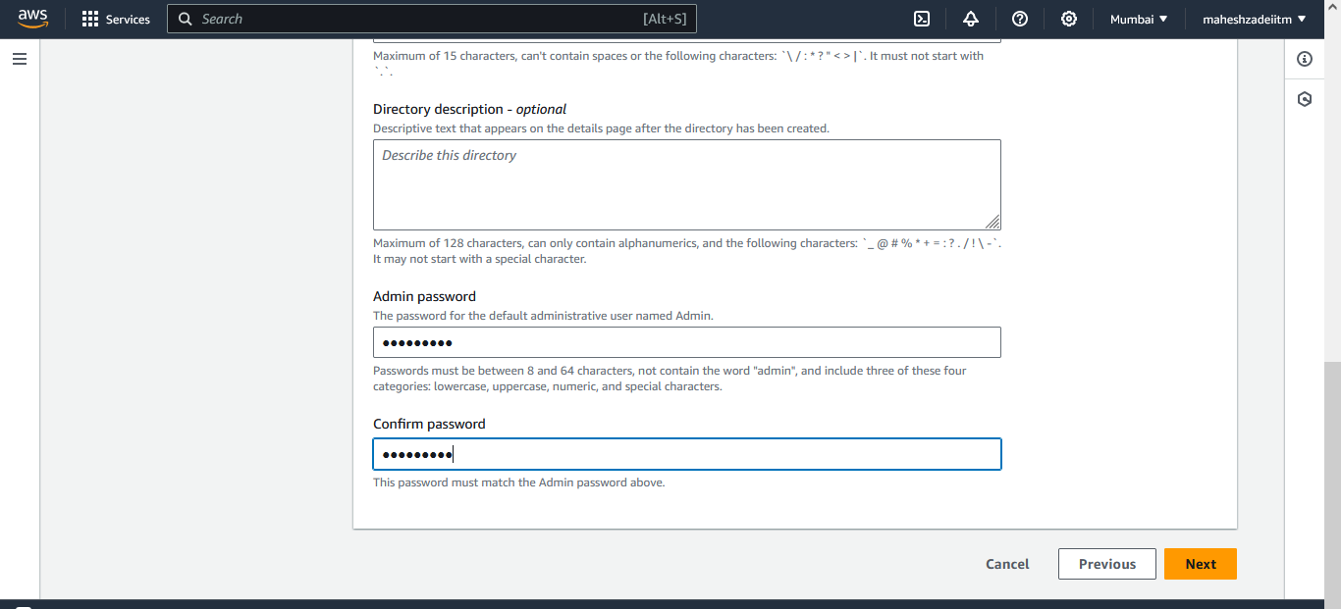

Choose your VPC

Choose your Public Subnet

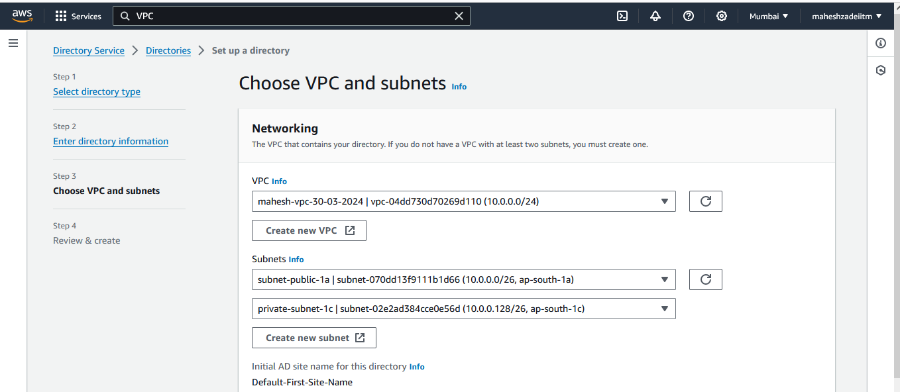

Need to choose two different subnets from two AZ.

Click on next

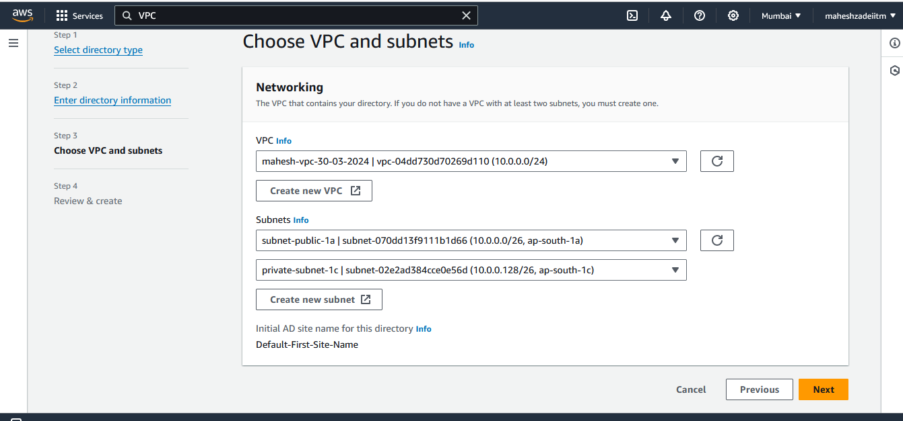

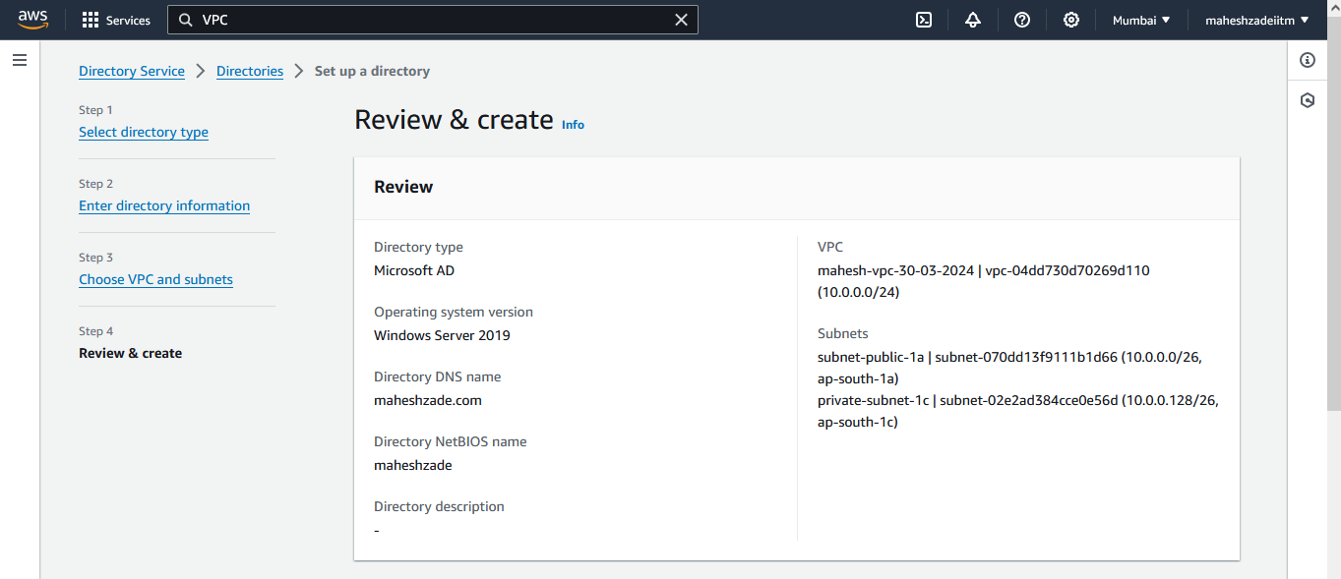

Click on create directory

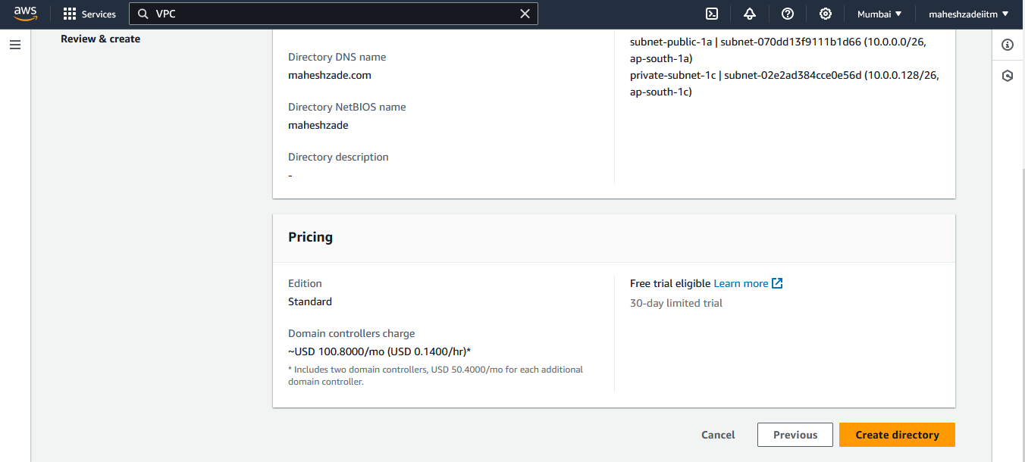

Then create a directorty

It will take 20 -45 minutes to create AD as shown below

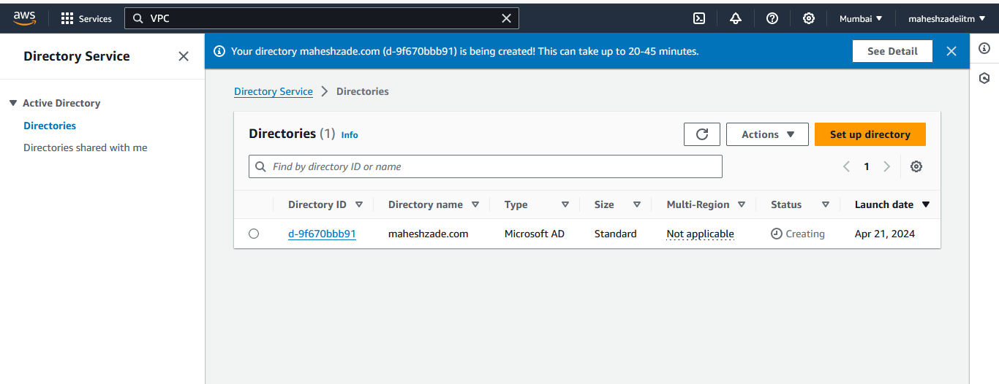

Your directory maheshzade.com (d-9f670bbb91) is being created! This can take up to 20-45 minutes

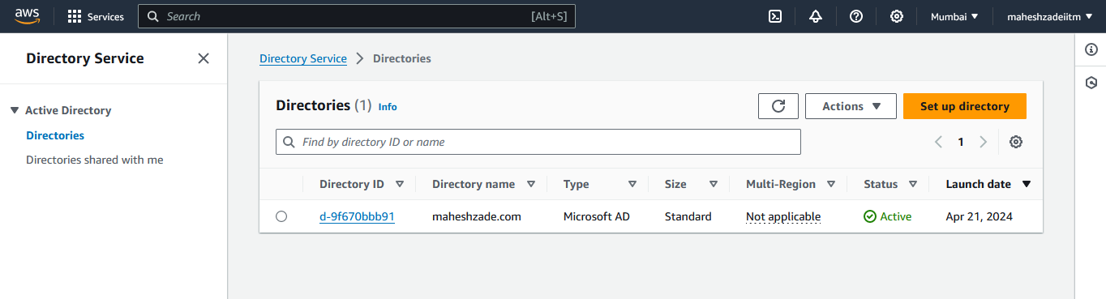

Step 3 - Create your windows EC2 instances if not already created (< 5 mints)

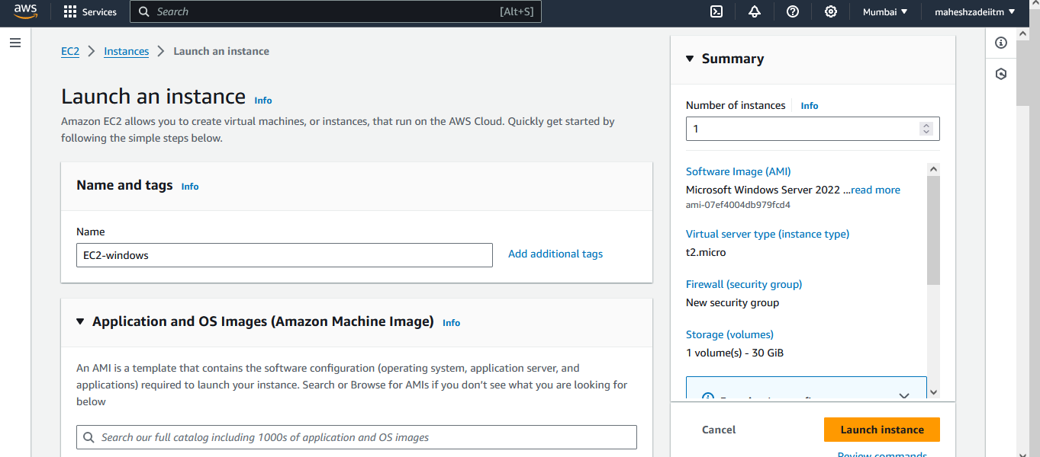

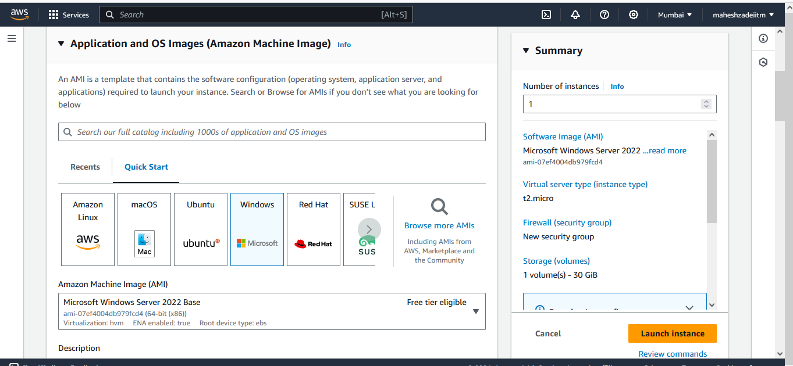

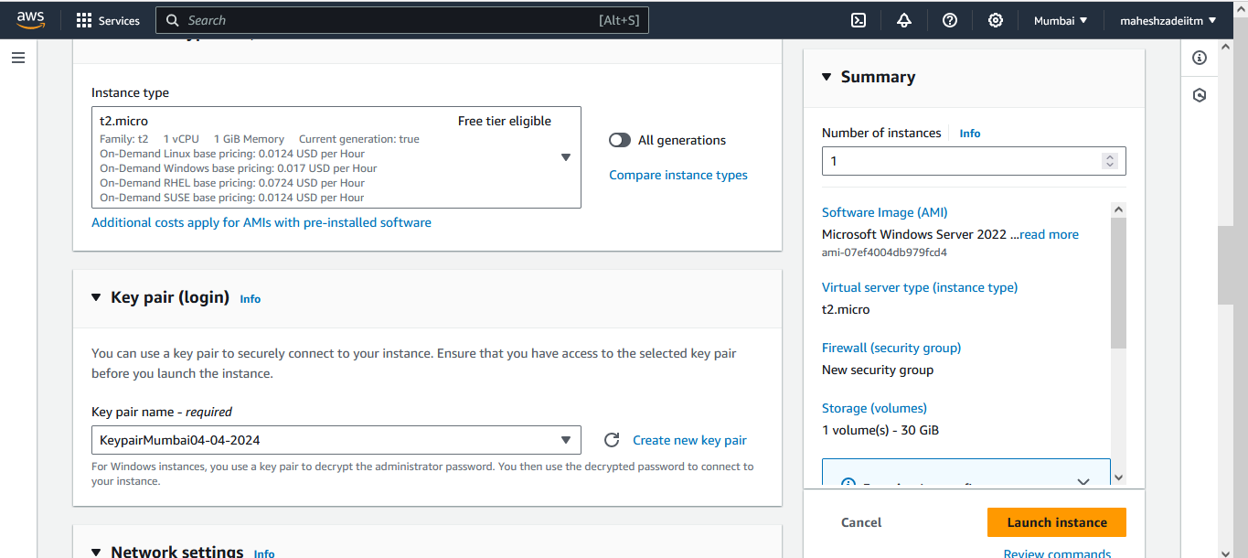

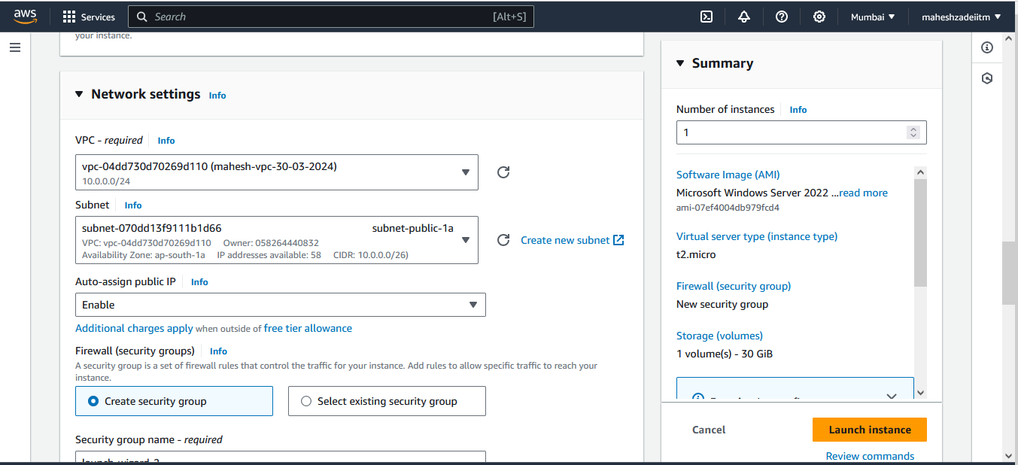

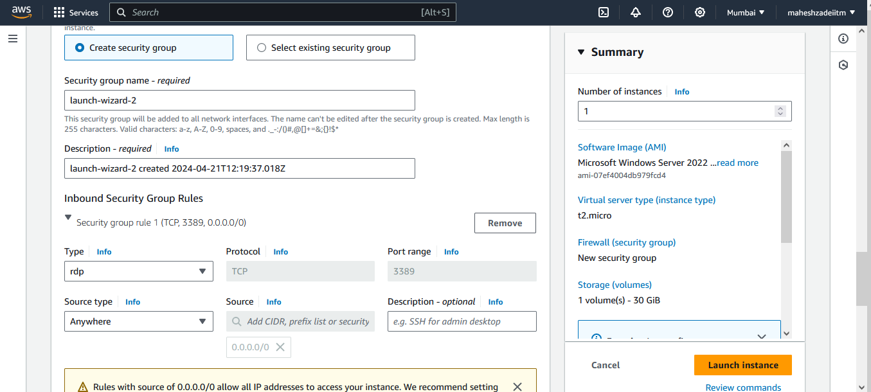

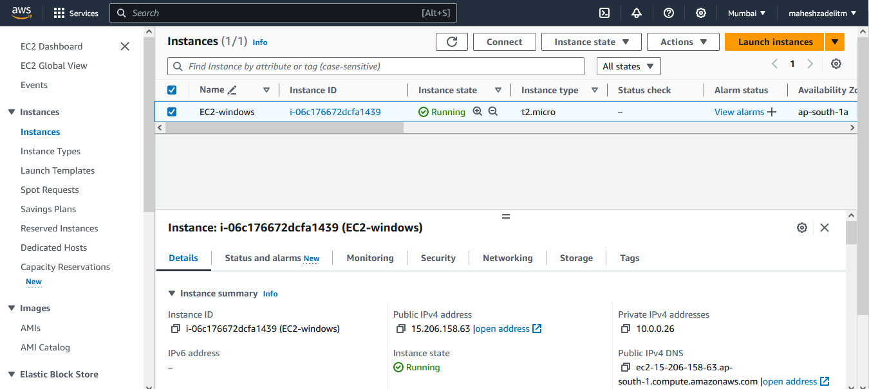

Copy Public IP 15.206.158.63 or click on connect

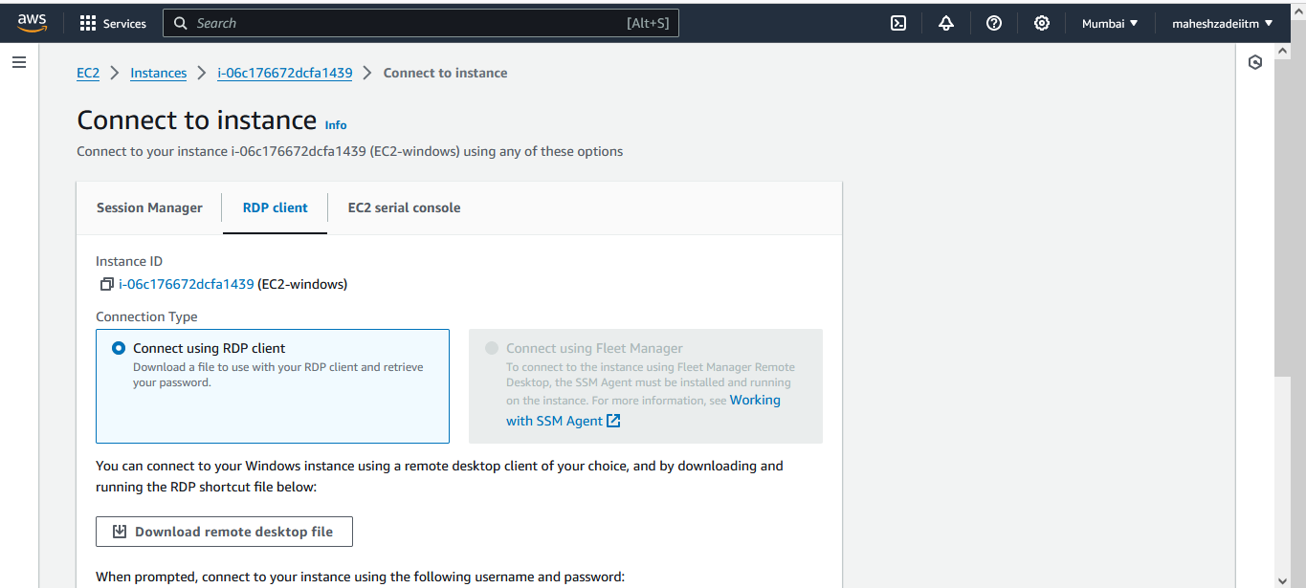

Download remote Desktop

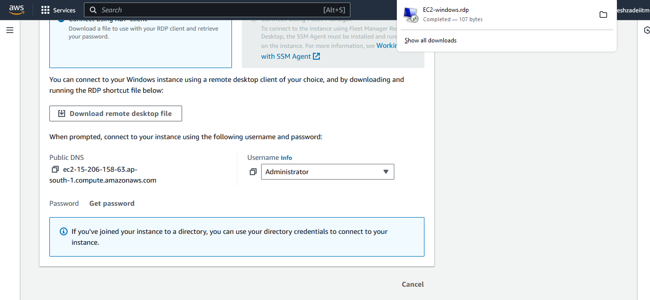

Select the Mumbai Region Key pair

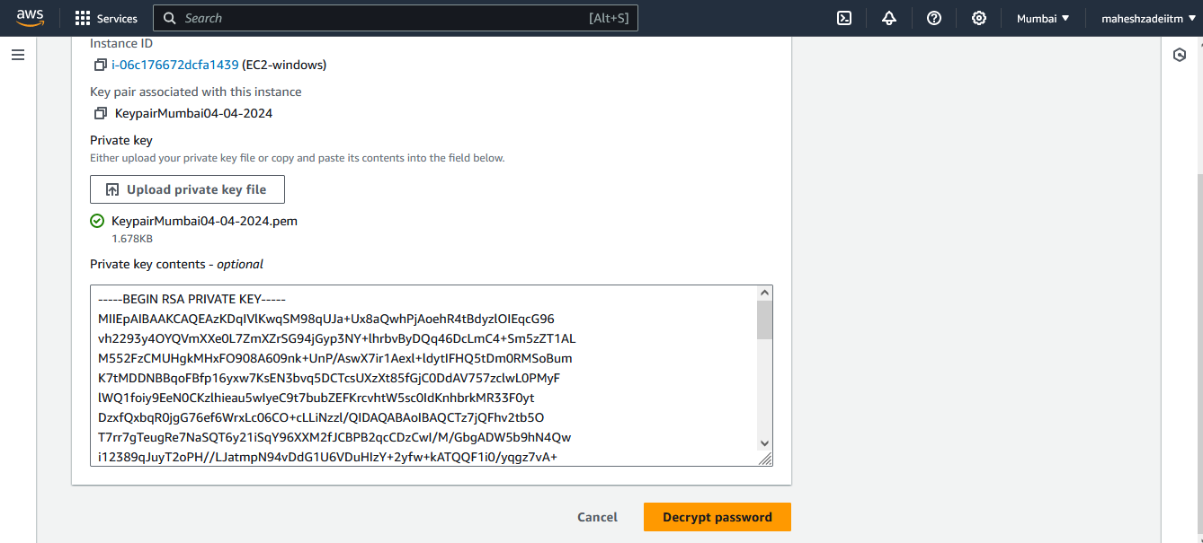

Click on decrypt Password

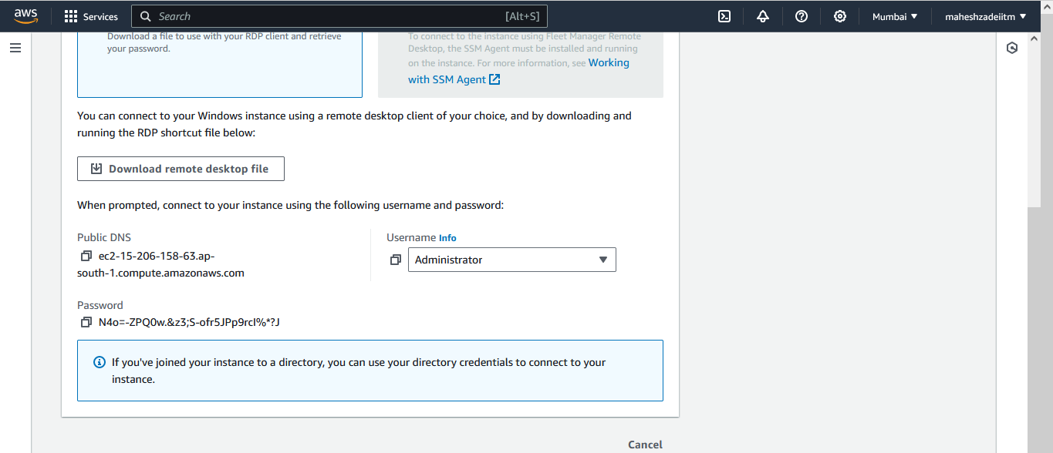

Now connect windows Machine via RDP

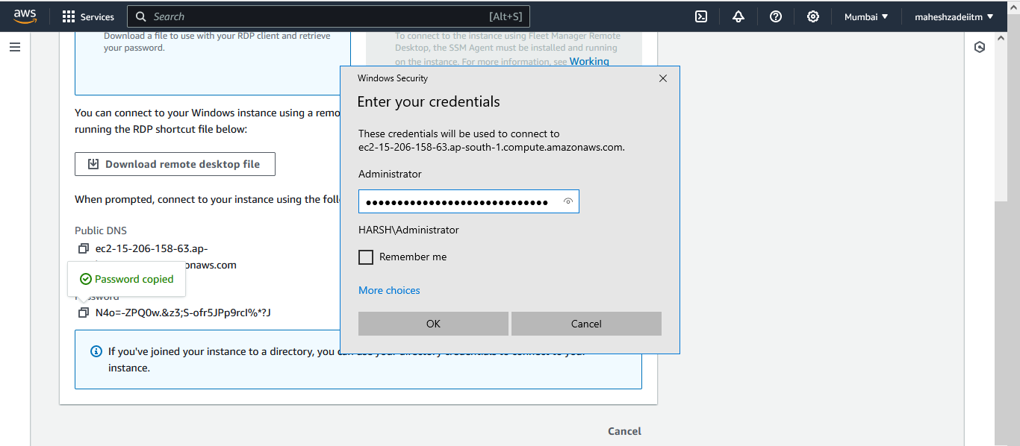

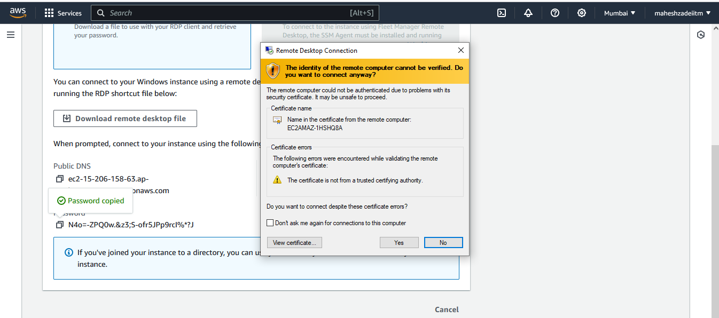

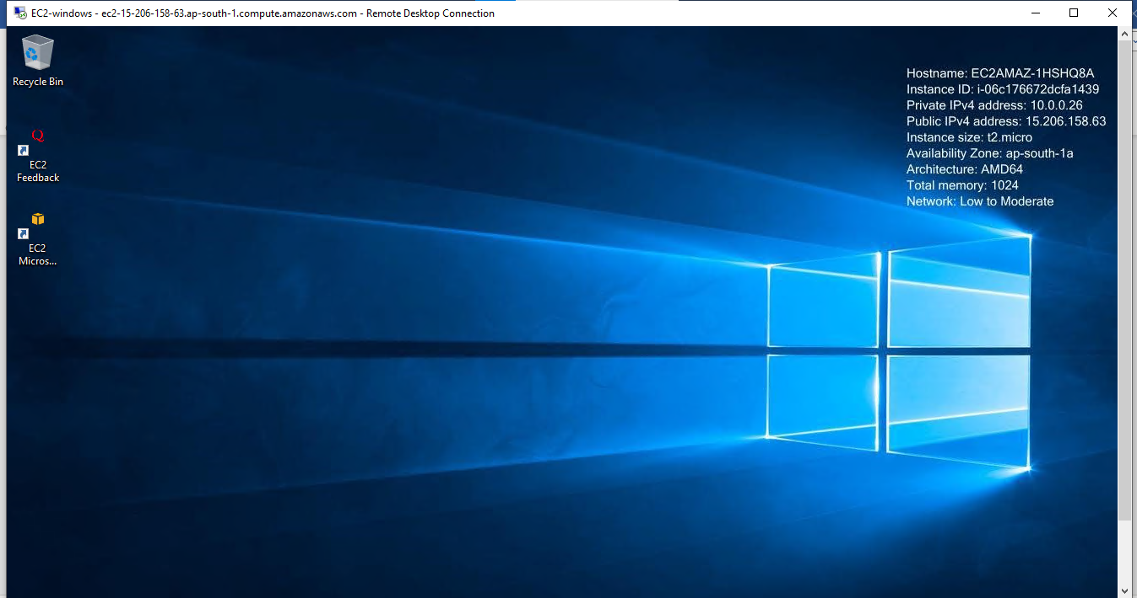

Windows Machine Connected .

Step 4 - Create a FSx only after your domain is ready (15 - 20 mints)

Go to FSx Service

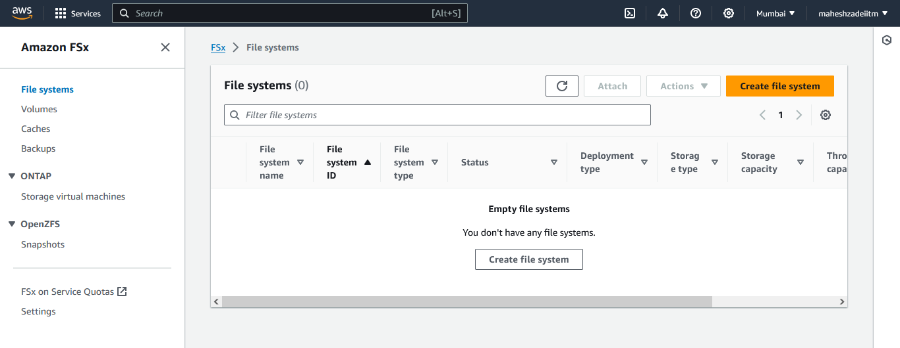

Click on create File System

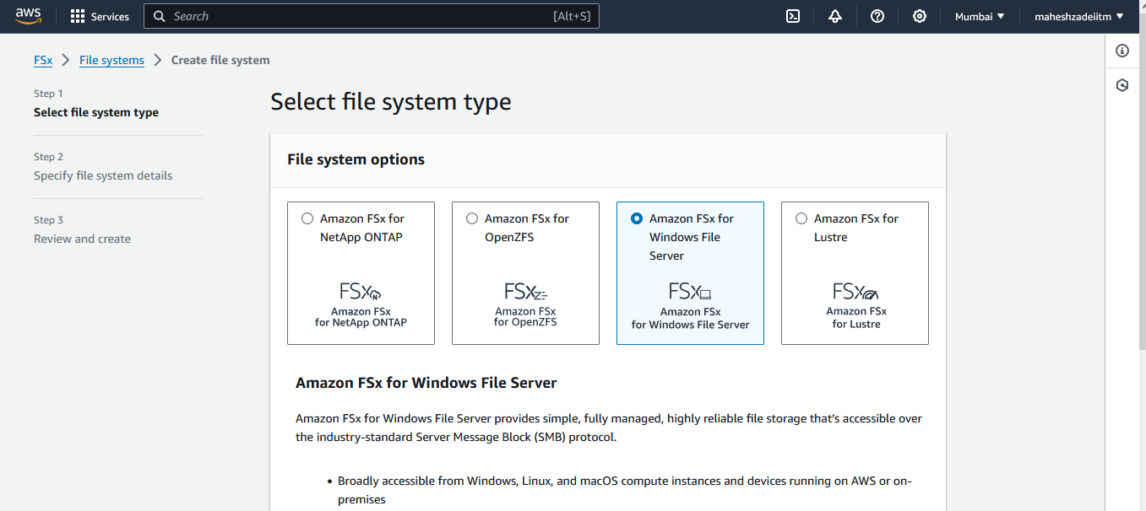

Click on next

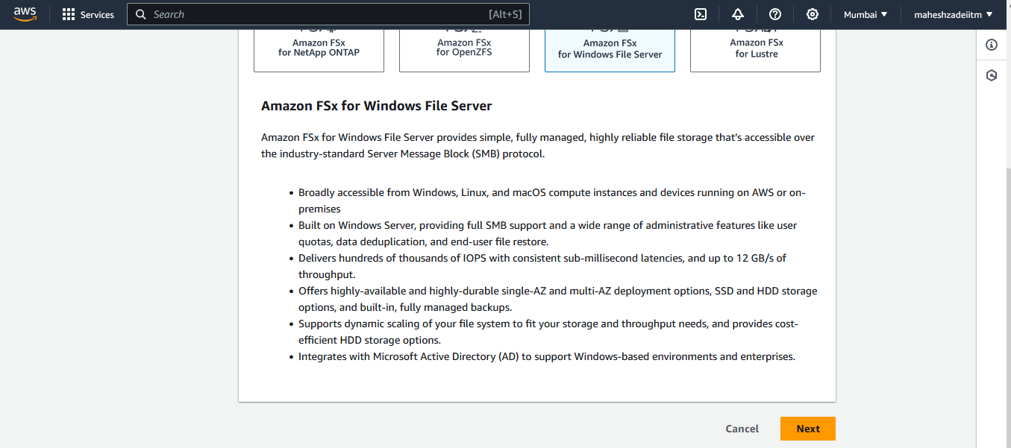

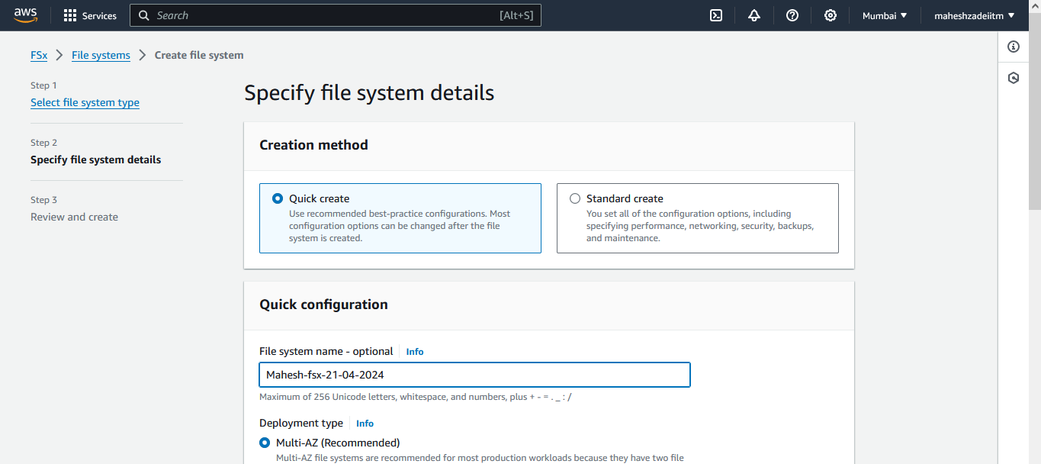

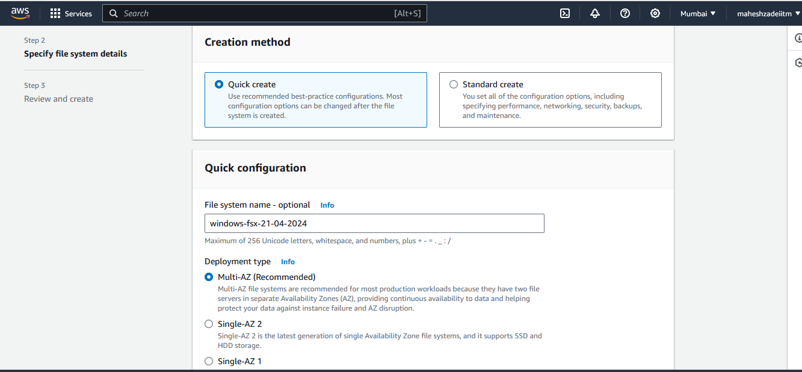

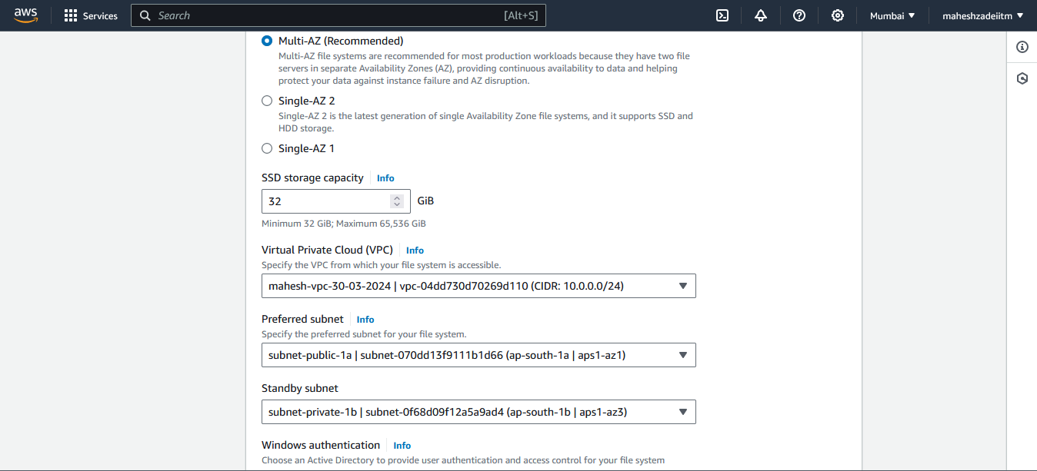

Select the VPC and Public Subnet where the EC2 Instance is created!

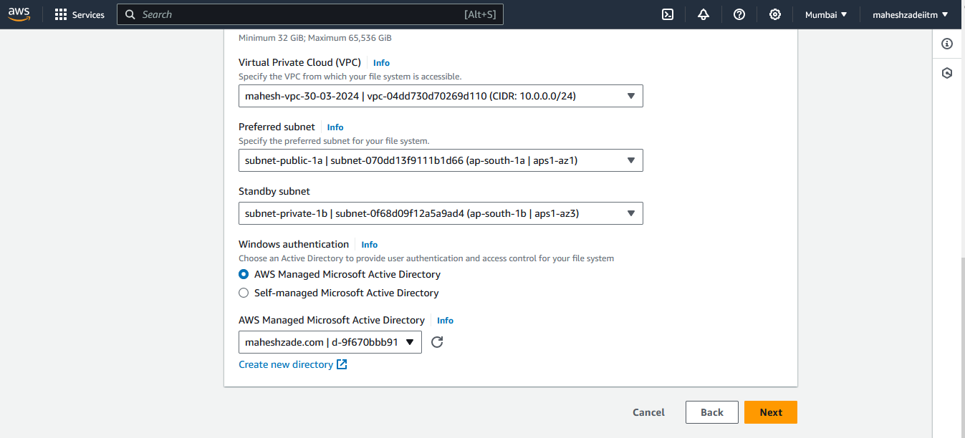

Select the Aws Created Ad Managed Microsoft active directory

Then click on next

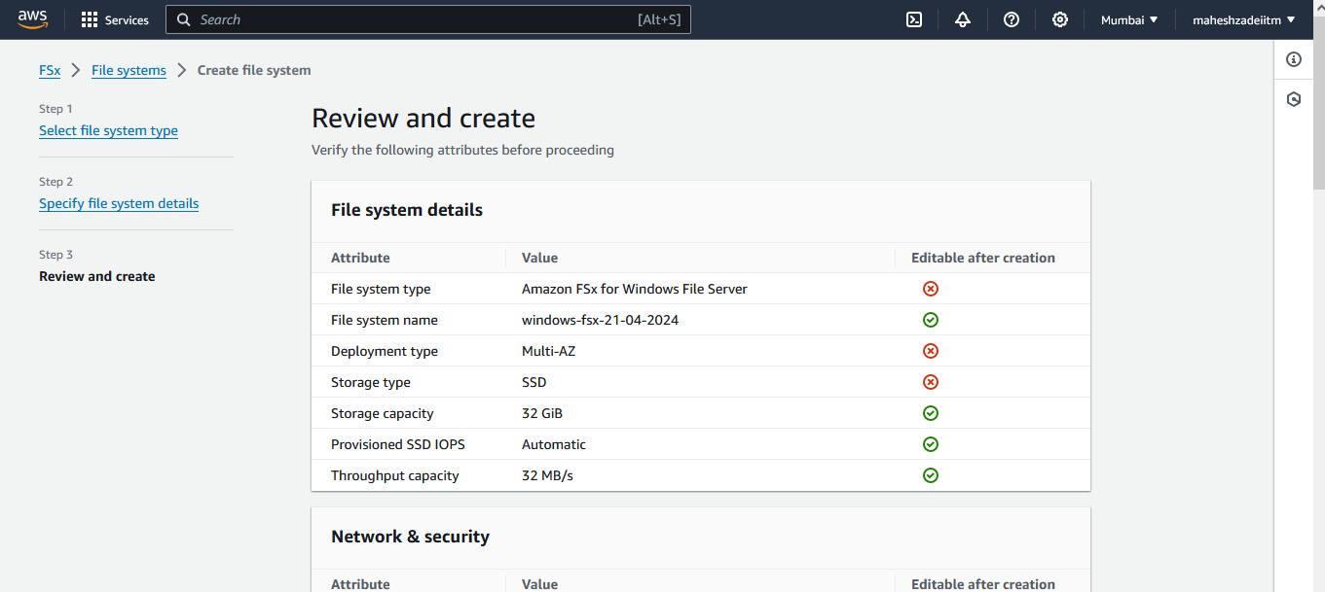

Click on create file system

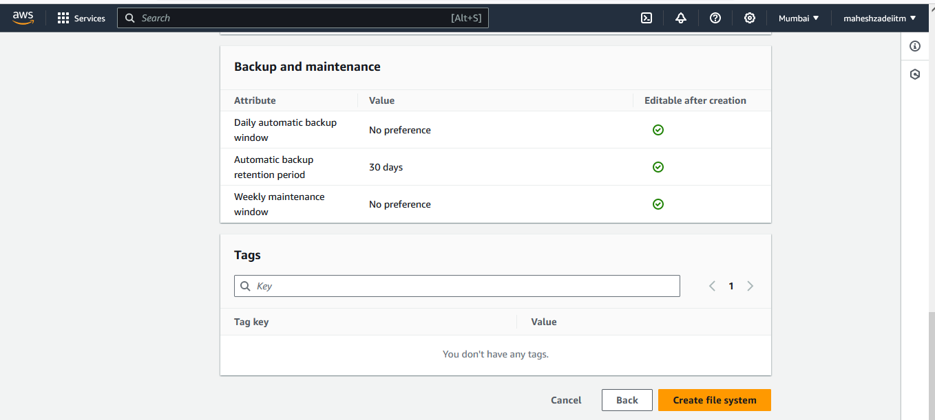

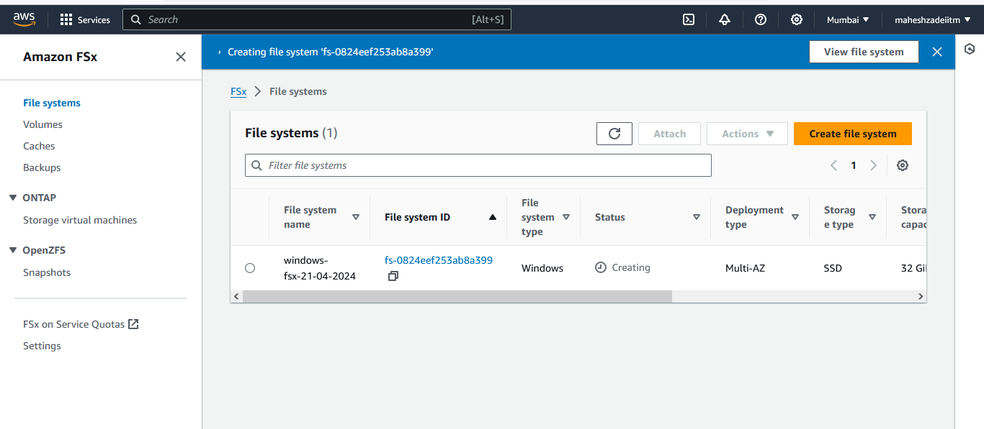

Wait till the Fsx Files System is available.

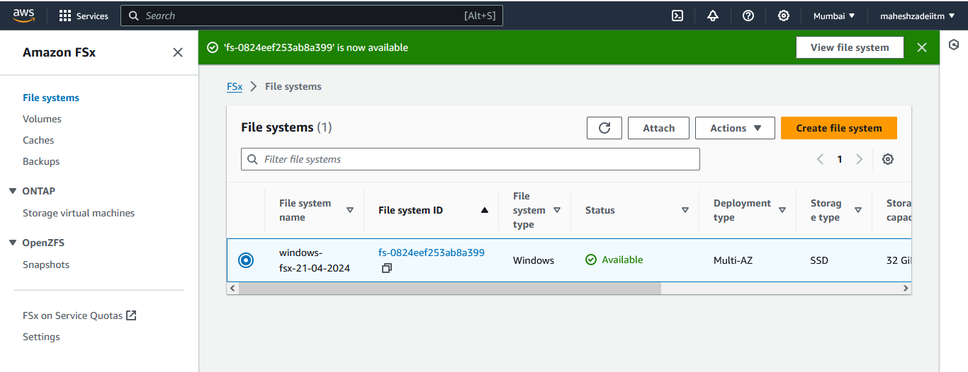

Now Go to EC2 Windows Machine and open the network and sharing

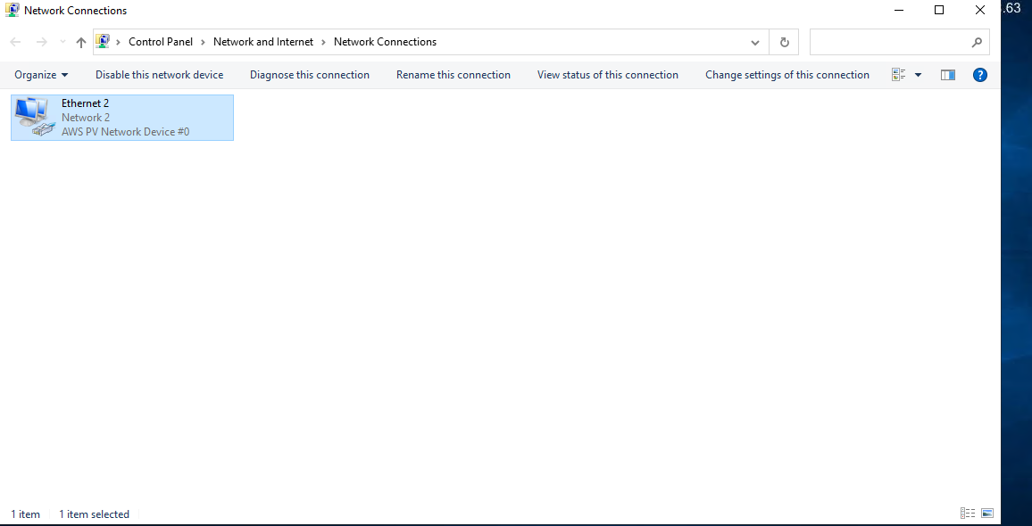

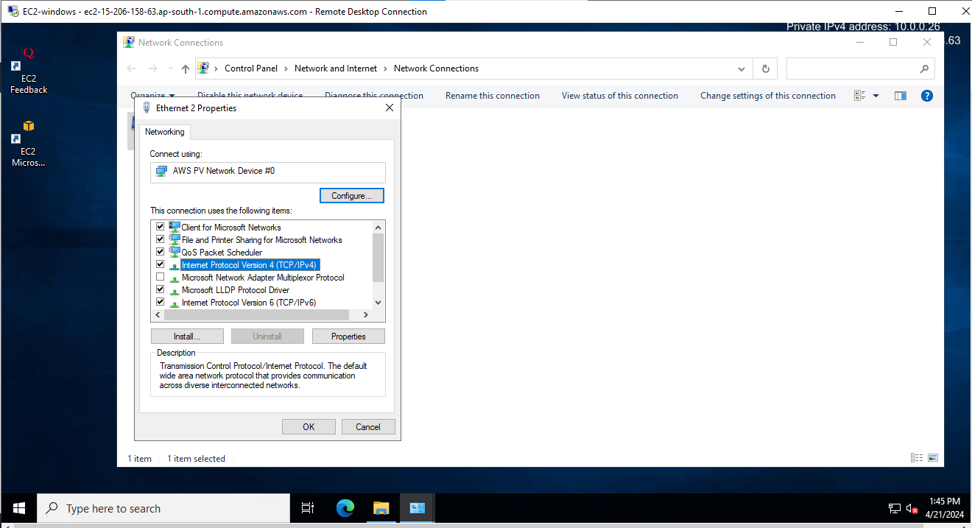

Go to Properties

And click on use the following DNS address

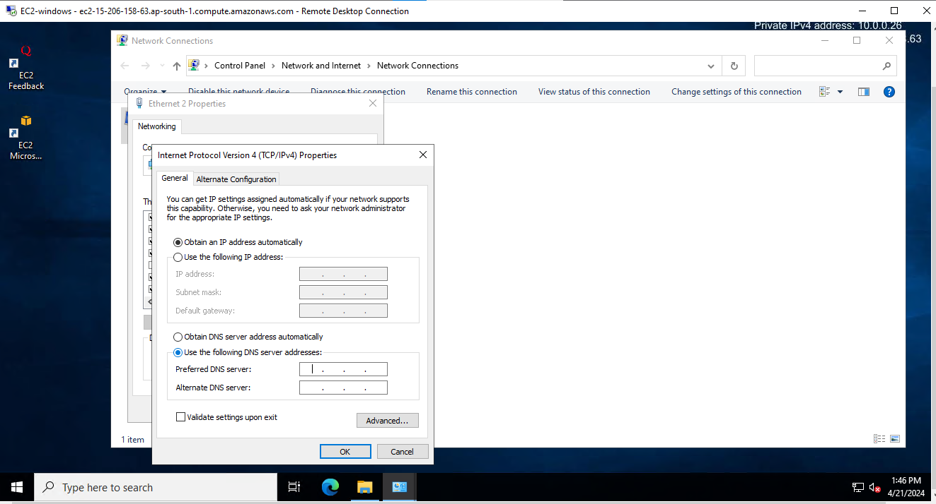

Now go to AD which is created and copy the both the DNS

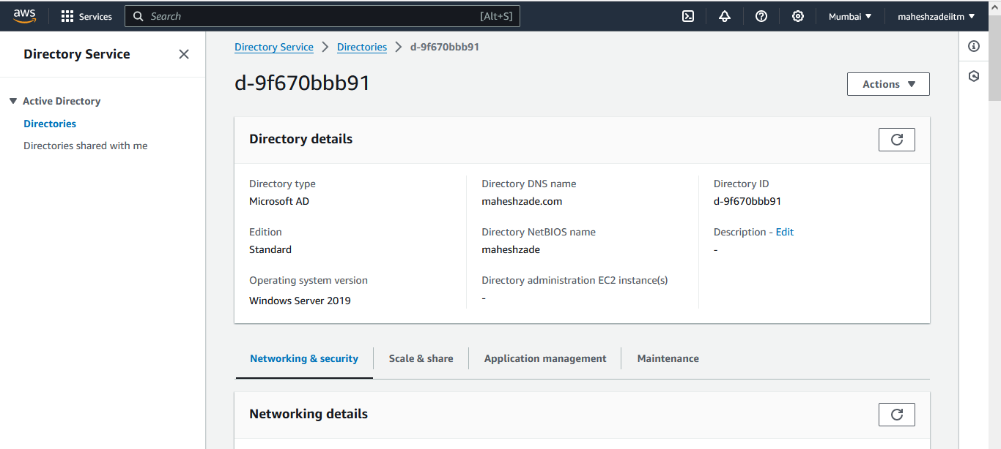

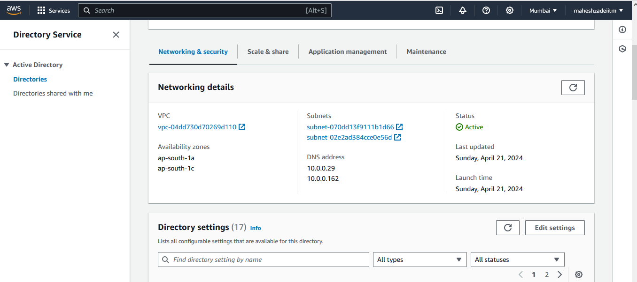

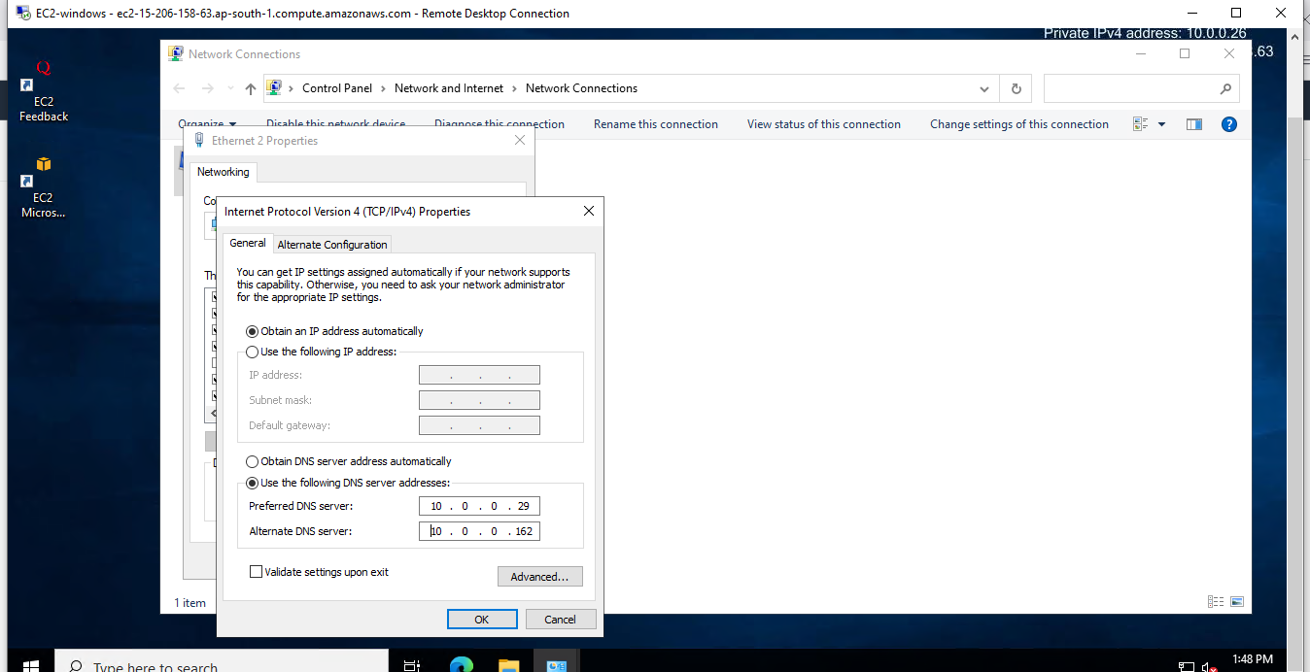

Paste in the EC2 Instance and click on ok

Now Go to This PC >> Right Click >> Properties

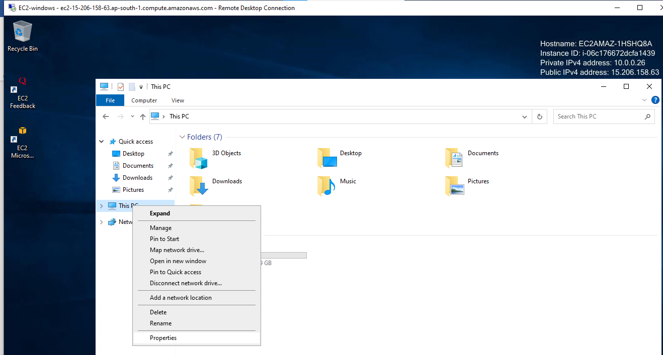

Go down

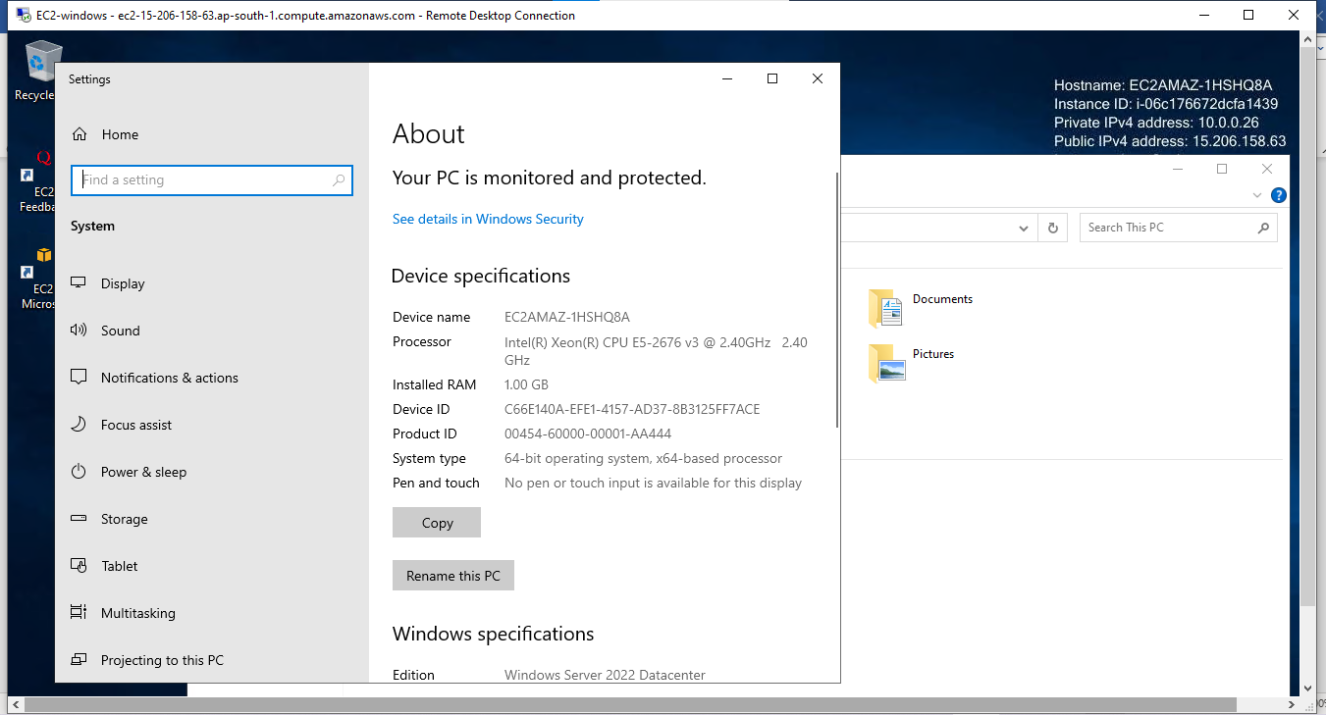

Click on rename this PC

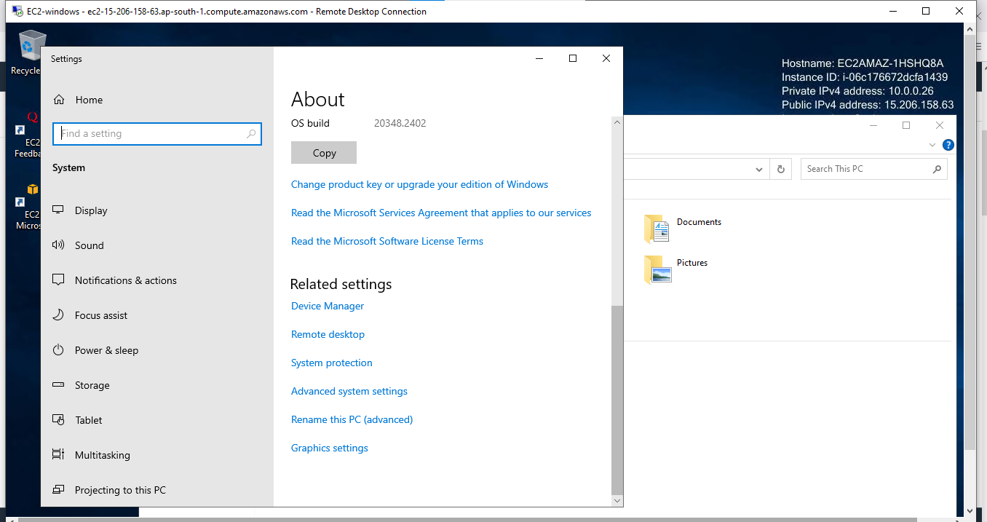

The click on change

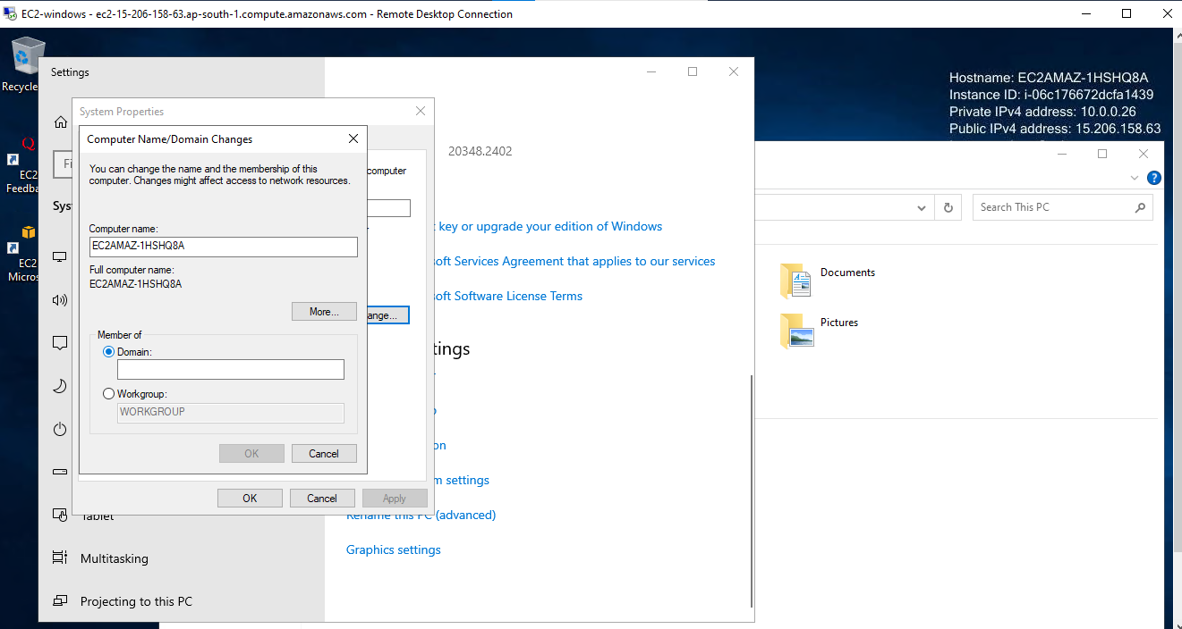

Click on domain and copy from AD Service

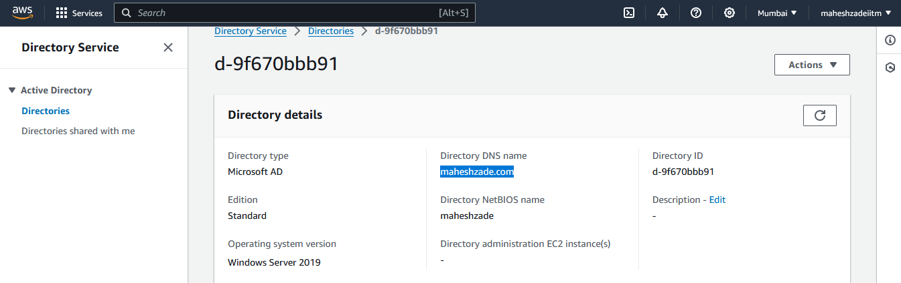

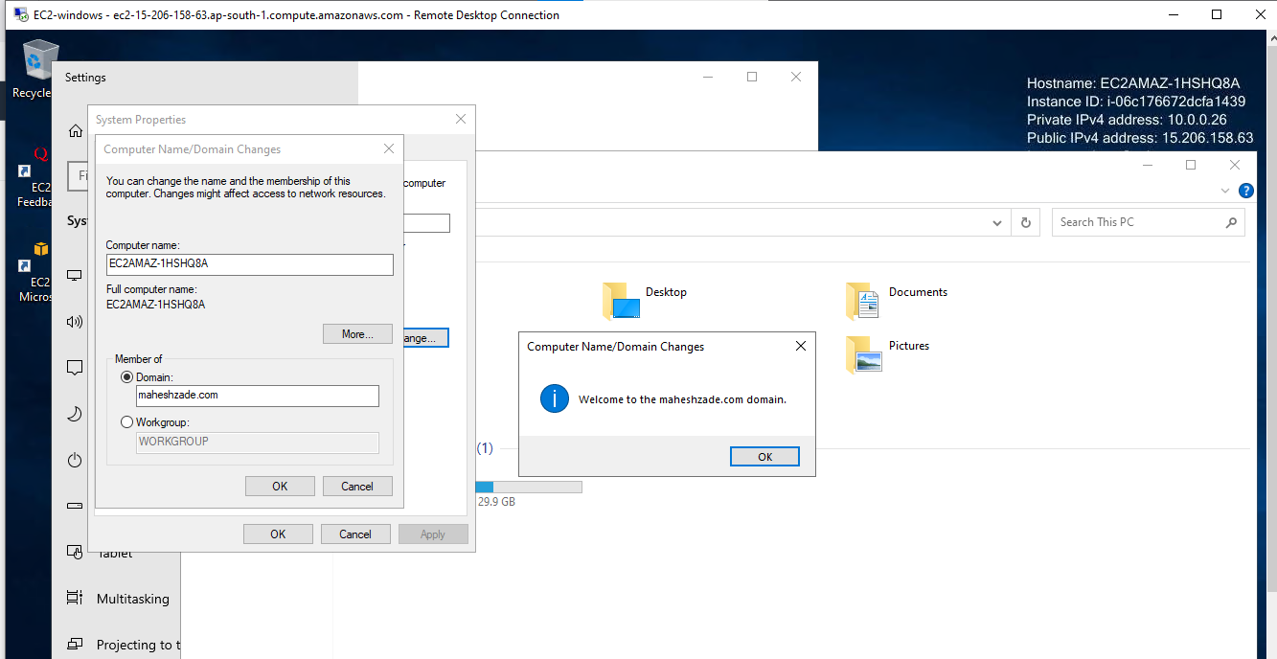

Restart the EC2 windows server

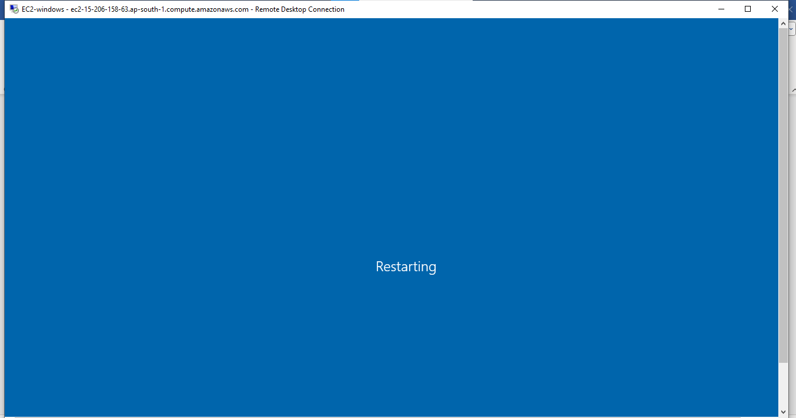

Check server is restarted and login again

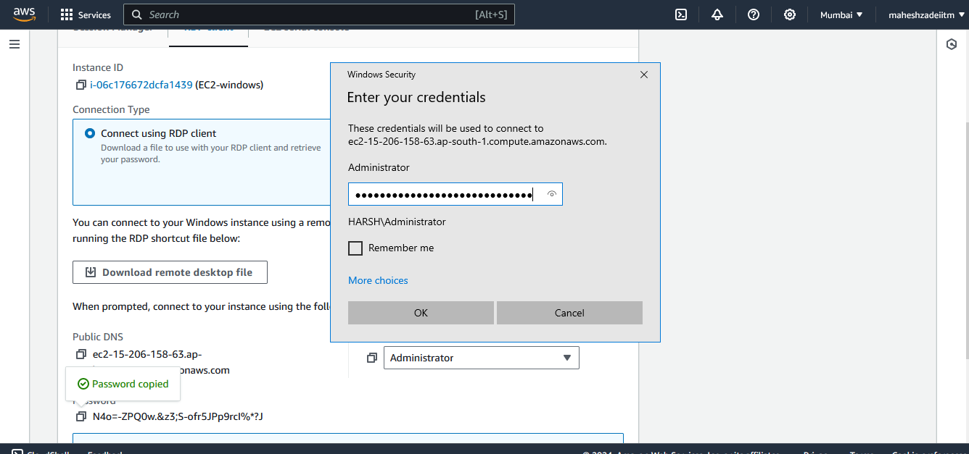

Now go to FSx and Click on attach

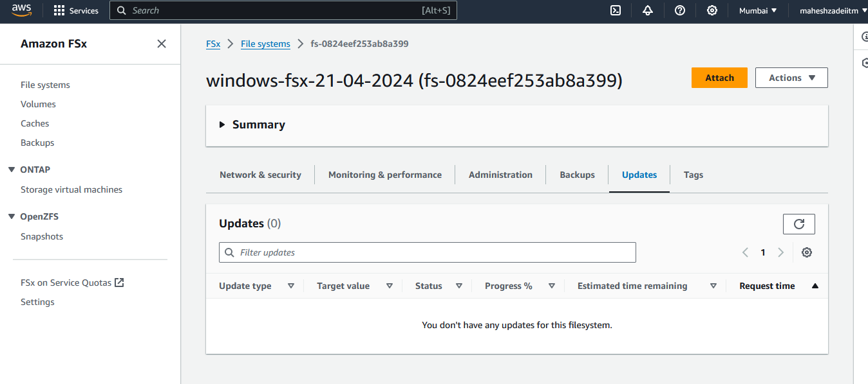

Execute the below command in windows EC2 Instacne

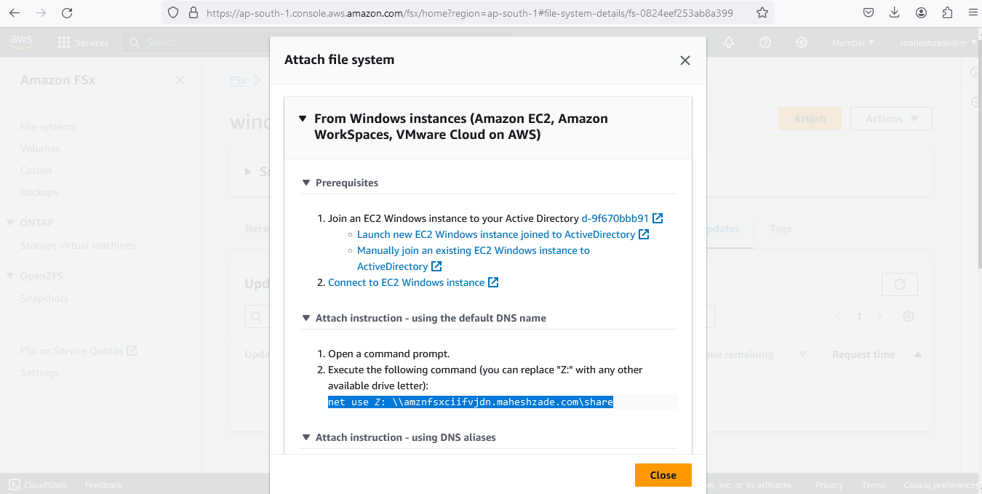

net use Z: [\\amznfsxciifvjdn.maheshzade.com\share](file:///\\amznfsxciifvjdn.maheshzade.com\share)

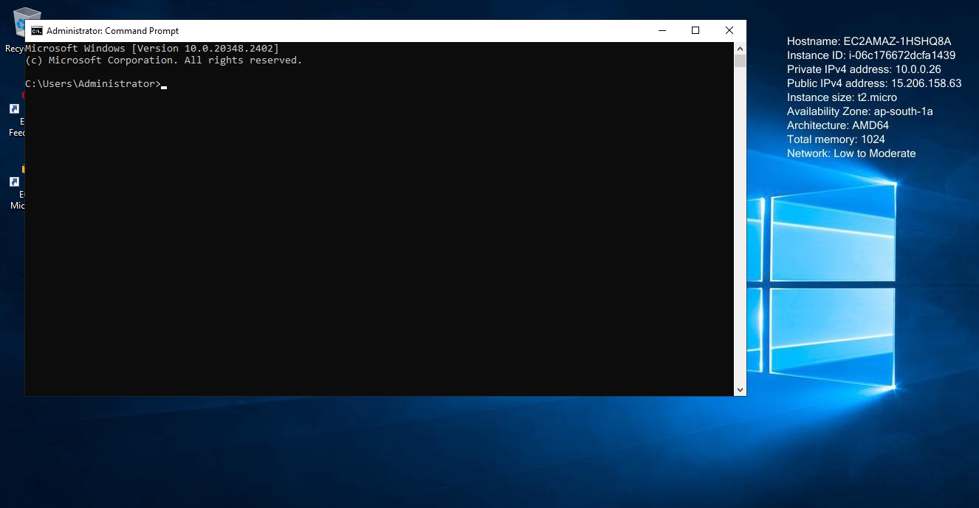

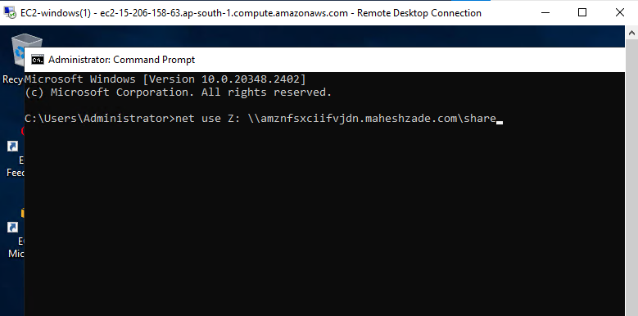

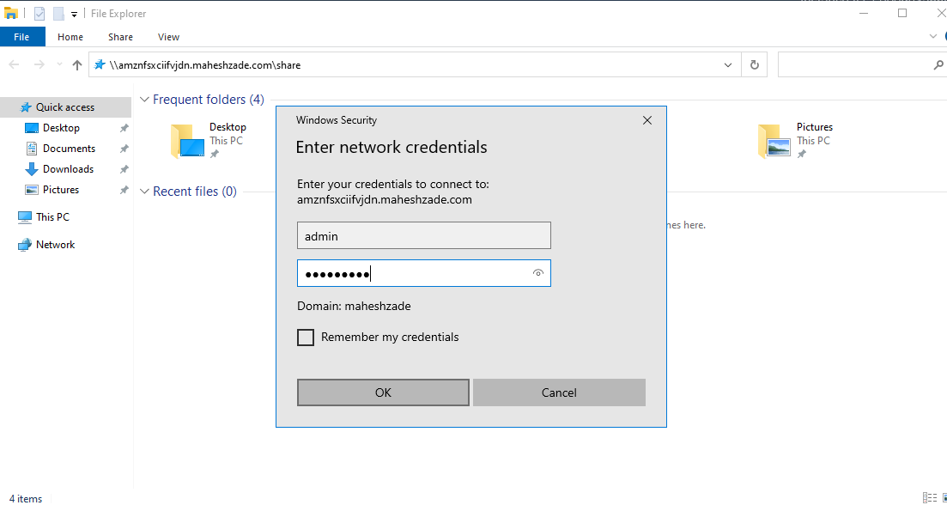

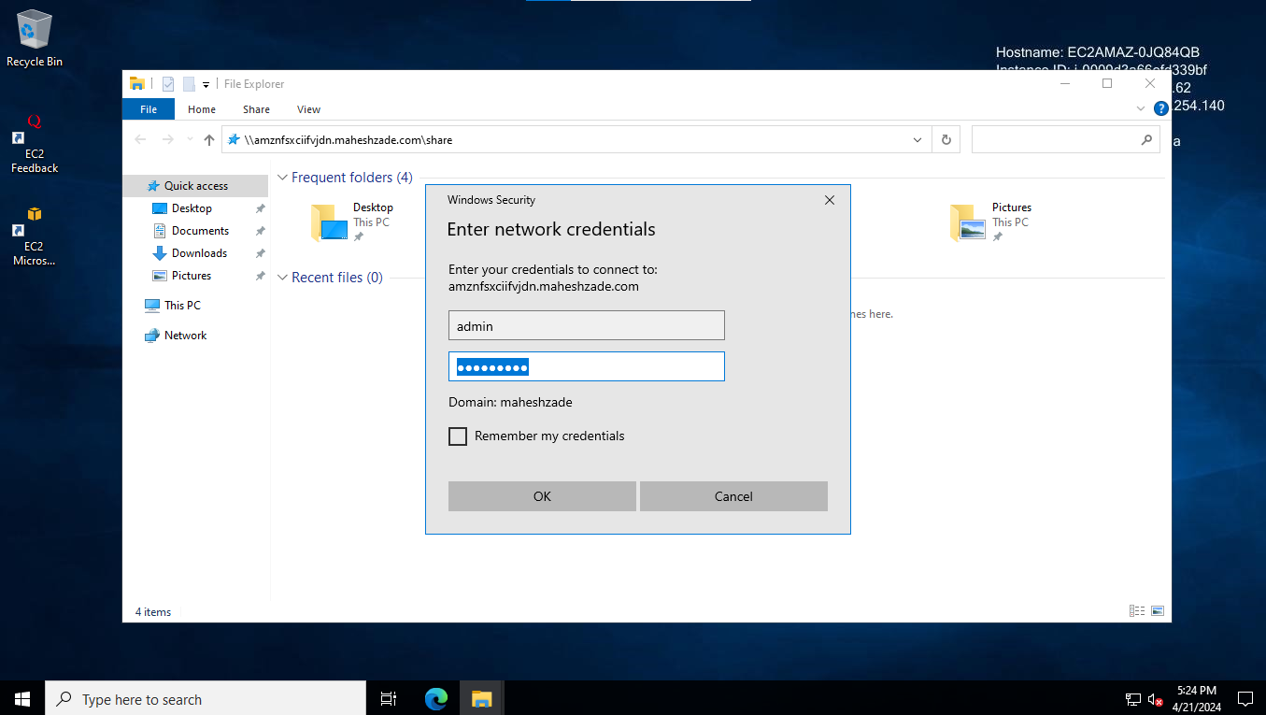

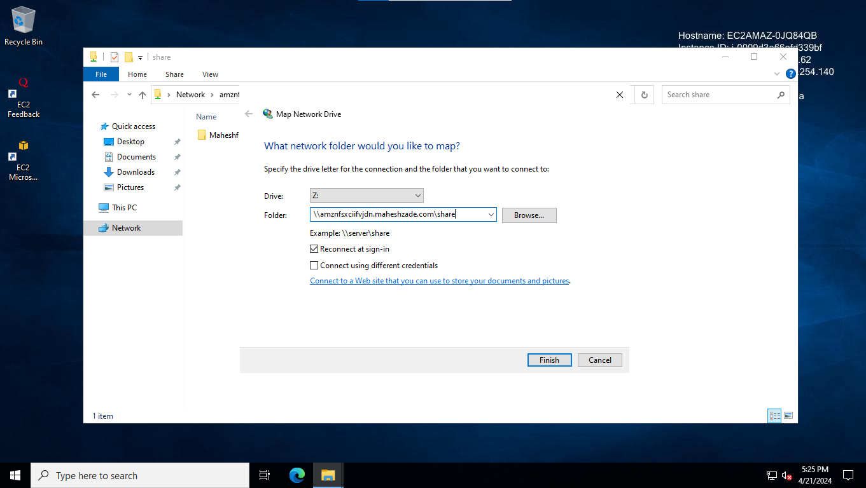

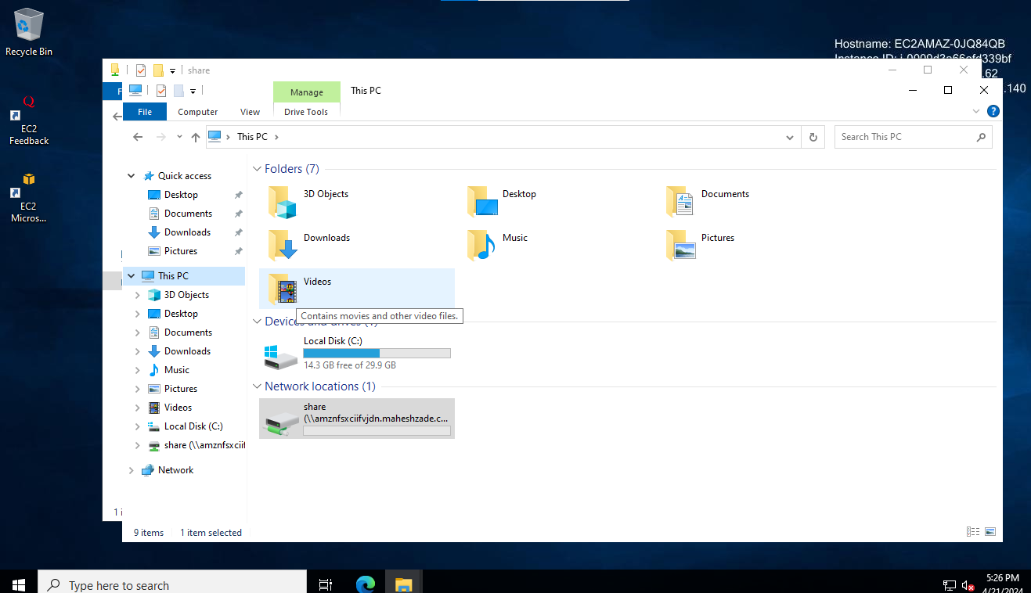

Its done now

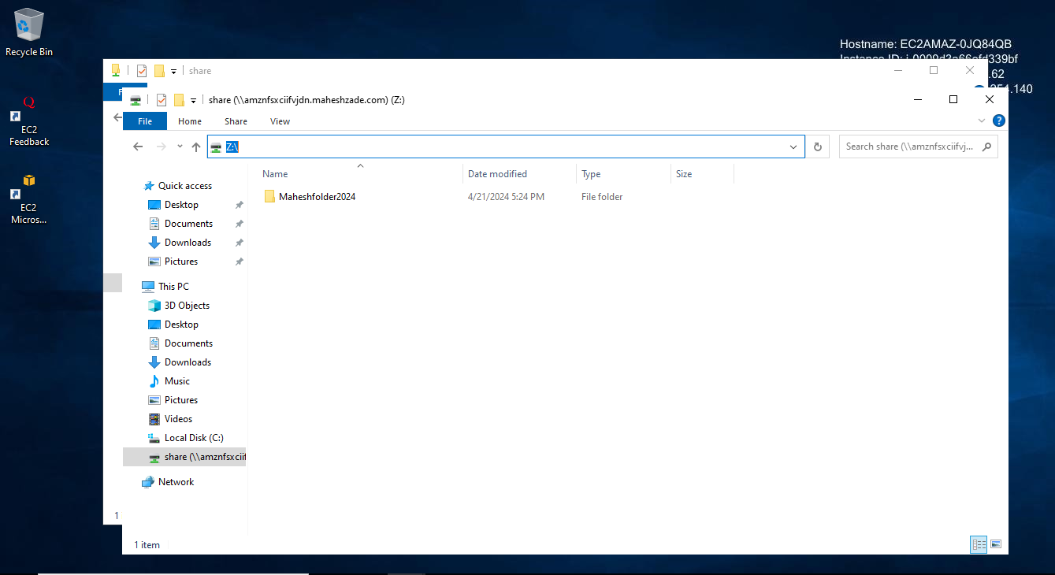

Thanks

Press enter